Put the title of the paper here with font Arial,
size 16pt, centered, length up to 2 lines

First + Middle (initial) + Last name∗1a(Superscript―*:Corresponding, 1:affiliation, a:footnote info),
Sullivan T. Smith^{*2}, Tanaka Ikarashi^{1a} and Ahmed M. Mohamed^{2b}

¹Affiliation (Department, Institute, Address, Country) with font Arial, size 9.5pt
²Department of Civil Engineering, Korean Advanced Institute for Science and Technology,
291 Daehak-ro, Yuseong-gu, Daejeon 305-701, Republic of Kiorea

(Received keep as blank , Revised keep as blank , Accepted keep as blank )

Abstract. This study aimed to develop a model to accurately predict the acceleration of structural systems during an earthquake. The acceleration and applied force of a structure were measured at current time step and the velocity and displacement were estimated through linear integration. ……

Keywords: complex terrain; typhoon wind field; CFD simulation; surface roughness length; topography

1. Introduction

Normally, strong winds have been associated with two types of wind in typhoon prone region. The first one is the nature wind and the other one is the typhoon, or say severe tropical cyclone. Many investigations about the vibration and buckling (static stability) characteristics of frames of various types have been carried out. Cheng (2011) have studied the elastic critical loads for plane frames by using the transfer matrix method. A general digital computer method has been described by Cheng and Xu (2012) ……

2. Section title: Level 1

The system examined, shown schematically in Fig. 1 is a beam of variable cross section, carrying a so called heavy tip mass M. Its mass moment of inertia with respect to the perpendicular axis at the centroid S is denoted by J_{S}. The publications (Abolghasemi and Jalali 2003, Younesian and Esmailzadeh 2010, Arvin and Bakhtiari-Nejad 2011) are considered also with rotating beams in which nonlinear oscillations are investigated. Analytical and experimental investigations on vibrating frames carrying concentrated masses with characteristics of frames have been studied by
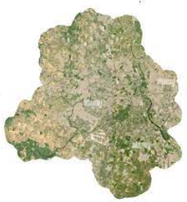
Fig. 1 Mesh grid of topographic model

using analytical solutions and the finite element method (Cheng et al. 2013a, b). ……

2.1 Numerical simulation procedure

One can write the extended form of the Hamilton’s Principle with the notations used in the present study as……
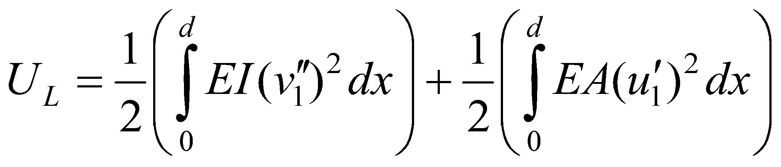 (1)
In consideration of different 10m height wind speed v10 and the power law exponent index α results shown in Table 2, the representative upstream typhoon wind fields at different directions used as the input data for training ANN model are determined, which is shown in Tables 1-2.……

3. Section title: Level 1

A finite element model is developed to represent a cracked beam element of length d and the crack is located at a distance d₁ from the left end of the element as shown in Figs. 2-3. Substituting Eqs. (3)-(4) in Eq. (7) yields the general equation for the local compliances as follows (considering that all K’s are independent of η; η: see Figs. 2(a)-(b)). In this regard, the circular area taking the bridge as a center with a proper radius shall be considered (see Fig. 1 and 3).…...

Table 1 Caption
 |  | Intact | DI | D2 | Intact | DI | D2
OF-1* | Mean | 2.63 | 2.62 | 2.53 | 3.34 | 2.67 | 2.46
OF-1* | SD | 0.041 | 0.369 | 0.123 | 0.290 | 0.444 | 0.207
OF-3 | Mean | 23.39 | 23.24 | 22.55 | 23.63 | 23.12 | 22.73
OF-3 | SD | 0.021 | 0.161 | 0.161 | 0.042 | 0.251 | 0.213
*OF-1: Observed Frequency for 1st mode; OF-3: Observed Frequency for 3rd mode

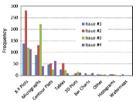 | 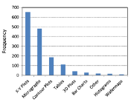
(a) Wind speed profile | (b) Wind direction profile
Fig. 2 ANN model output training data for upstream typhoon wind field coming from N direction with exponent 0.22

4. Section title: Level 1

4.1 Subtitle: Level 2

4.1.1 Subtitle: Level 3
On the day of the beam test, the respective control cylinders were capped and tested in compression to determine the compressive strength of concrete. Table 1 shows that the average values of the 56-day compressive strengths are 69.2 and 68.7 MPa for Series V and S specimens, respectively. The results indicate that although the two mix designs were different, they had similar compressive strengths……

Subtitle: Level 4
Chondros et al. (1998) have developed a continuous cracked beam vibration theory for the lateral vibration of cracked Euler-Bernoulli beams with single-edge or double-edge open cracks….

5. Conclusions

A numerical simulation procedure for predicting directional typhoon wind fields over complex terrain has been proposed in this study.
- The reduction of natural frequency depends on the crack depth and crack location.
- Higher drops in the in-plane natural frequency are observed when the crack is located near the roots or corners of the frames…………

Acknowledgments

The research described in this paper was financially supported by the Natural Science Foundation ……

Conflict of Interest
Statement

References

References to be styled In IEEE format.
NOTE:
The length of the article must not exceed 10 pages in any case whatsoever.
The similarity index/ plagiarism and AI content of the article must not exceed 10% and 5% respectively.
The original article of the author(s) submitted to TIMES should not have been submitted to any other conference/ journal for consideration.

Authors’ background

Your Name | Title* | Research Field | Personal website

*This form helps us to understand your paper better, the form itself will not be published.

∗Corresponding author, Professor (or Ph.D., etc.), E-mail: email address ª Ph.D., E-mail: email address ^{b} Ph.D. Student, E-mail: email address

